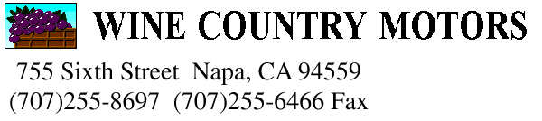
Kelly Dicker kd@wcmotors.com

Re: Scott Soldis 5-20-11
Fiat 124 1982 VIN 2FAASB5C8188592 Lic no 1FAU322
Date of manufacture 6-81
Last registration sticker June 1996 Miles shown 66366

Right ft Brake caliper came in dangling in steering- was removed because brakes were stuck? Scrounge used set of brake pads, caliper anchor wedges and lock pins And reinstall caliper to be able to roll car better.
Top needs renewal/ no back window.
Interior needs complete refurbish incl seats, Dash cracked
Cooling system hoses need renewal/ Cooling system flush
Battery dead/ old Fuel is probably ancient and recommend at minimum clean fuel tank, if not boil out/ Recommend renew fuel hoses all, including injector hoses at engine. Engine turns over by hand freely- did not try to start. Ignition system parts old/ Looks like rodents have been nibbling on wiring/ plug wires/ Enigne oil pan has minor dents- recommend change engine, trans and diff. Oils Differential pinion oll seal leaks.

All brakes appear to be in some form of sticking,- recommend 4 wheel caliper overhaul/ brake hoses/ pads and rotors as nec. Right lower rear track bar is bent ( body to diff. Trailing arm Bar).
Front suspension needs rebuild, incl upper and lower control arm bushings,
Tie rod ends, center link replacement. All tires are weather cracked-split
Obviously needs timing belt renewal before starting the car- recommend all front oil seals and water pump be replaced prior to starting the car. Head gaskets most usually fail if not replaced after sitting this long.

Body has a few areas of rust, and body dings, but overall the body is in pretty good condition/ No major rust under vehicle.
Due to the amount of things that would be necessary to make this car roadworthy, we recommend that it be offered as a parts car. There are many good parts on the car that could be salvaged, but the cost of restoration would be prohibitive and outweigh the eventual worth of a completed car.

